AIR FORCE JUNIOR ROTC

LEADERSHIP EDUCATION **(Master Sergeant Rory W. Brack**)

***DRILL ACTIVITY FOR THE WEEK OF 23 MARCH 2020.***

Cadets are to read the “Individual Guidon Bearer procedures, and practice each of the movements using a pole or pole like object about the size of a broom or mop. If possible, go online and search for guidon videos to watch.

**INDIVIDUAL GUIDON BEARER PROCEDURES**

1. **Order Guidon** – The guidon bearer holds the guidon in a vertical position and keeps the ferrule (the bottom part of the pole) on the ground beside the right foot. The guidon bearer holds the staff with the right hand in the “V” formed by the thumb and the fingers extended and joined. The right hand and arm behind the staff (the main part of the pole) with the arm bent naturally and the staff resting against the hollow of the shoulder.



1. **Carry Guidon** – The guidon bearer grasps the staff with the left hand while at the same time loosening the grip of the right hand on the staff. The guidon is raised vertically with the left hand, letting the staff slide upward through the right hand until the ferrule is approximately 6 inches from the ground. The guidon bearer then regrasps the staff with the right hand and cuts the left hand away smartly to the left side. Execute Carry Guidon on all preparatory commands except Parade Rest, Flight Attention, Present Arms, Extend and Close March (Halted), Count Off and Close Ranks.

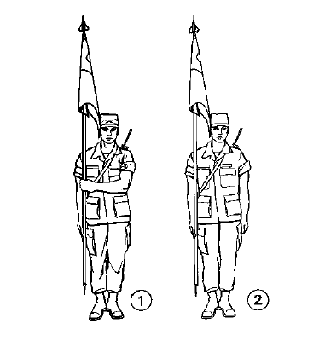

1. **Parade Rest** – Execute by sliding the hand up the staff while inclining the staff of the guidon forward at arm’s length with the hand at waist level.

