Space
TEK: Know that there are patterns among the Sun, Earth, and Moon. Identify and compare the Sun, Moon, and Earth. Earth rotates every 24 hours causing day and night, and the apparent movement of the sun across the sky.

FEATURED SCIENTITST: Copernicus, Galileo, Kepler, Ptolemy

The moon is Earth’s closest neighbor in space and the brightest object in the night sky.

Sun
Moon

Orbits

Earth

The earth and the moon revolve around the sun on their orbits.

- Revolve: to travel in a closed path such as an orbit

- Orbit: Earth’s path around the sun is its orbit.

As Earth orbits the sun, it rotates on its axis.

- Rotate: to spin in place

- Axis: an imaginary line that passes through Earth’s center at its North and South poles. The moon and the sun also have axes.

The earth, moon, and sun are always rotating!

Axis

When a location on Earth is facing the sun, it is day time in that place. When a location on Earth is facing away from the sun, it is night time in that place.

Night time

Sun
Day time

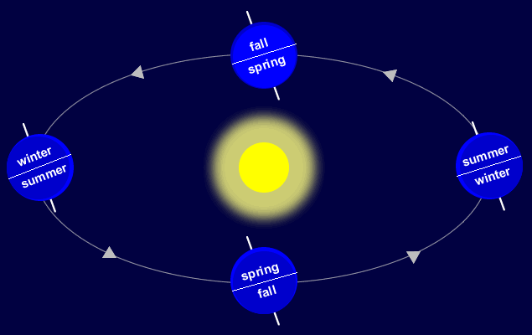
SEASONS: The four seasons occur due to the tilt of Earth on its axis and position of the Earth as it revolves around the sun. If the northern hemisphere is experiencing summer the southern is experiencing winter. The same is true for fall and spring.

The Moon’s Surface
When the moon first formed, its surface was hot, molten lava. As the surface cooled, it formed a rocky crust.
Similar to Earth Different from Earth_______
Hills, valleys plateaus, mountains, NO atmosphere, weather, liquid water, extinct volcanos, ice at polar caps life, plants, or daily changes to surface

The moon orbits, or revolves around the earth. It takes 27.3 Earth days for the moon to make one full rotation.
So why is the moon lit up at night?
Sunlight is reflected off of the moon! As the moon’s position changes, we see different shapes and phases.

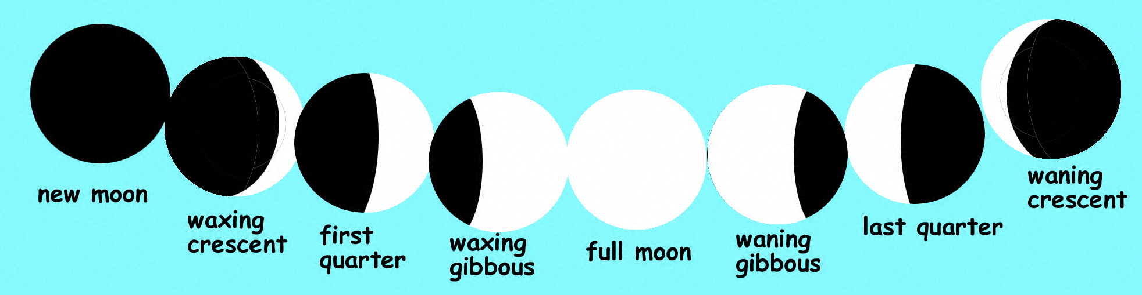
MOON PHASES (4th grade material)
Eclipses
*occurs when one object passes through the shadow of another. They can only happen during a new moon or a full moon. The sun, moon, and earth must all be lined up. Only 7 eclipses happen each year, 2 lunar and 5 solar. Most eclipses are partial and very few are total.
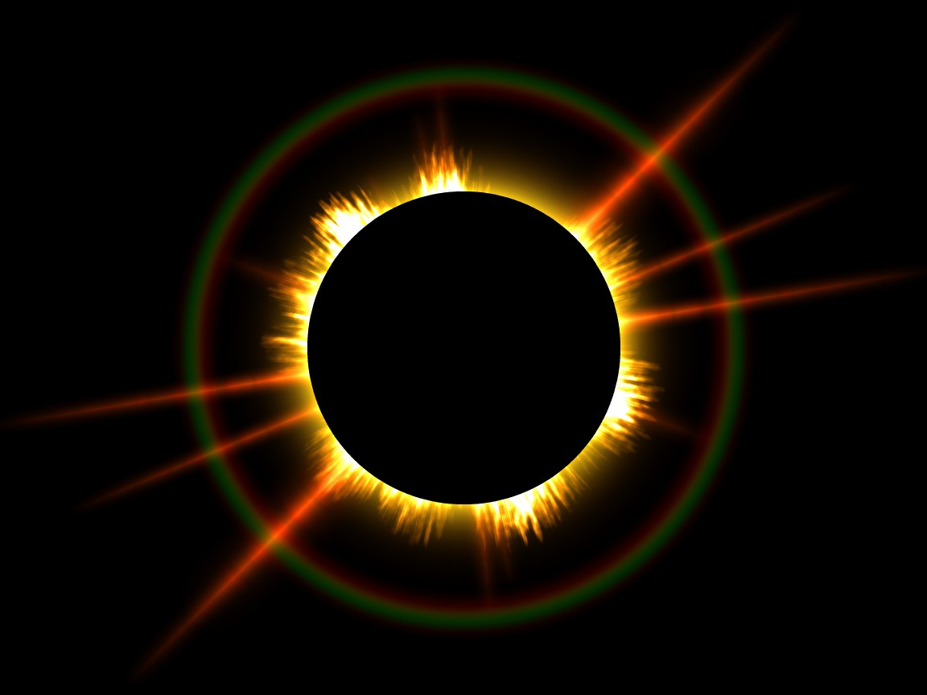
- Total Eclipse: This happens when the moon completely covers the sun. The sky darkens and only the sun’s outer ring of light can be seen. A total eclipse will only last for 7 ½ minutes.

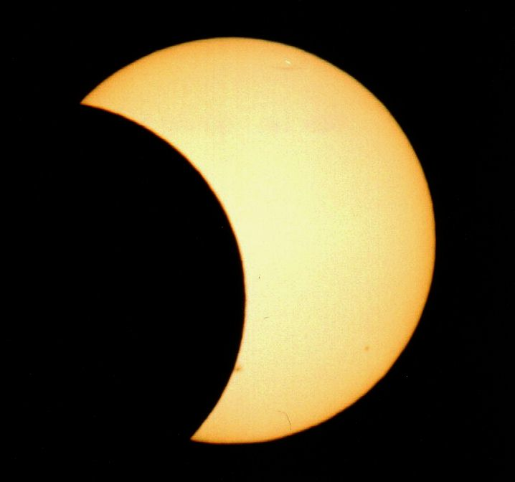
- Partial Eclipse: This happens when Earth passes through part of the moon’s shadow.

Solar Eclipse

Sun
Earth
moon

A solar eclipse occurs when earth passes through a new moon’s shadow.

Lunar Eclipse

Sun
moon
Earth

A lunar eclipse occurs when the full moon passes through Earth’s shadow. When Earth passes directly between the sun and the moon, it blocks the sun’s light. The moon will look orange-red because Earth’s atmosphere bends certain colors of light, especially red.
The Sun
*All energy comes from the sun!!!*
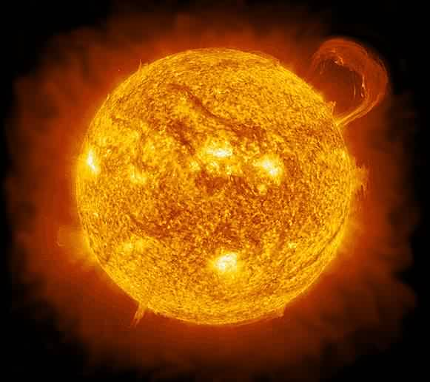
*The sun is made of gases.*

Prominence-
- Definition: A violent storm on the sun
- Looks like huge bright arches of gas on the sun
- The arches can be as high as a million kilometers or more

Solar Flares-
- Definition: A storm on the sun that shows up as bright bursts of light on the sun’s surface
- Usually does not last more than an hour
- Temperature in that region is twice as high as anywhere else on the sun
- Huge energy release into space

Solar Wind-
- Definition: Continuous stream of high-energy particles released into space from the sun’s corona.
- May increase during a solar flare.
- Can affect radio and telephone communication on Earth

Sunspots-
- Definition: Dark areas on the sun
- Cooler than the rest of the sun
- Storms in the sun’s lower atmosphere that move across the sun
- Can be very small or very large

Planets

- The inner planets are Mercury, Venus, Earth, and Mars.
- The outer planets are Jupiter, Saturn, Neptune, and Uranus.
- The 3 dwarf planets are Ceres, Pluto, and Eris.

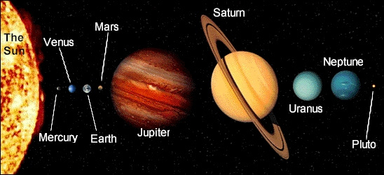
Each of the 8 major planets has its own orbit around the sun. You can remember the order of these planets by memorizing the phrase “Sunday, My Very Excited Mother Just Served Us Nachos”.

