ECOSYSTEMS: The student knows that interdependence occurs among living systems and the environment and that human activities can affect these systems.

8.11A describe producer/consumer, predator/prey, and parasite/host relationships as they occur in food webs within marine,
freshwater, and terrestrial ecosystems

8.11B investigate how organisms and populations in an ecosystem depend on and may compete for biotic and abiotic factors such as quantity of light, water, range of temperatures, or soil composition

8.11C explore how short-and long-term environmental changes affect organisms and traits in subsequent populations

8.11D recognize human dependence on ocean systems and explain how human activities such as runoff, artificial reefs, or use of resources have modified these systems

ECOSYSTEMS “Organisms and Their Environment”

Populations are INTERDEPENDENT!
*They depend on each other for survival!*

Physical Environment-includes ALL non-living things such as soil, weather, air, water, landforms

Biotic: Living or once living factors

Abitoic: factors that are not alive such as air, water, rocks, temperature

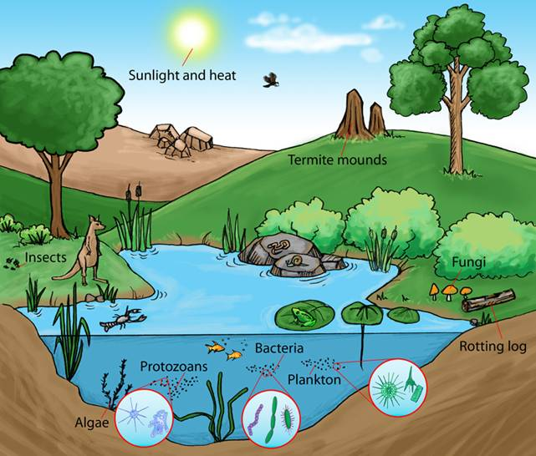

Niche: each individual has a job or role in the environment.
Individual: a single organism

Population: individuals of the same kind living in the same environment.
Habitat: where the population lives.

Community: All the populations in an environment living together.

**Each level builds upon the next.**

3rd level consumer:
Omnivore- eats plants an meat

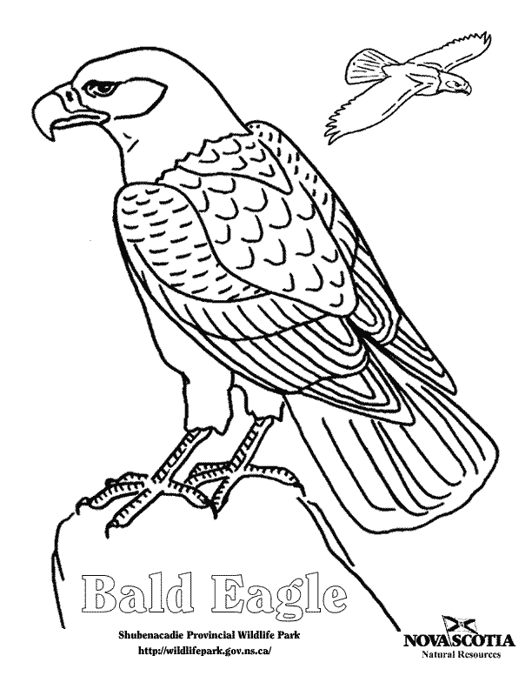

CONSUMERS: must eat to get energy

2nd level consumer: Carnivores – eats meat only

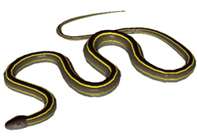

1st level consumer: Herbivore
Eats plants only

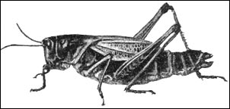

Producers: make own food

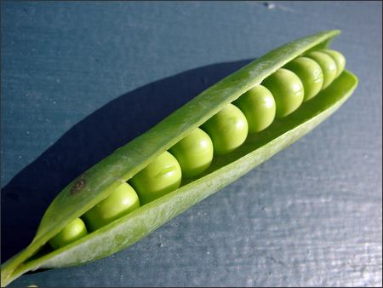

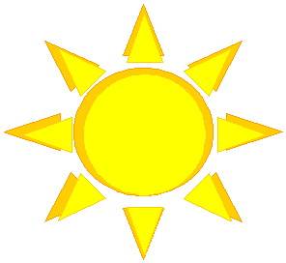
- Producers: They use sunlight to make the food they need; plants use energy to grow and reproduce. They store energy in roots, stems, and leaves.

- Scavengers: They feed on bodies of dead animals. Examples: vultures, hyenas
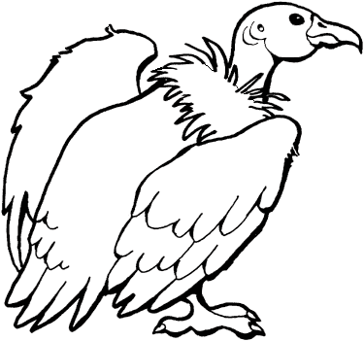
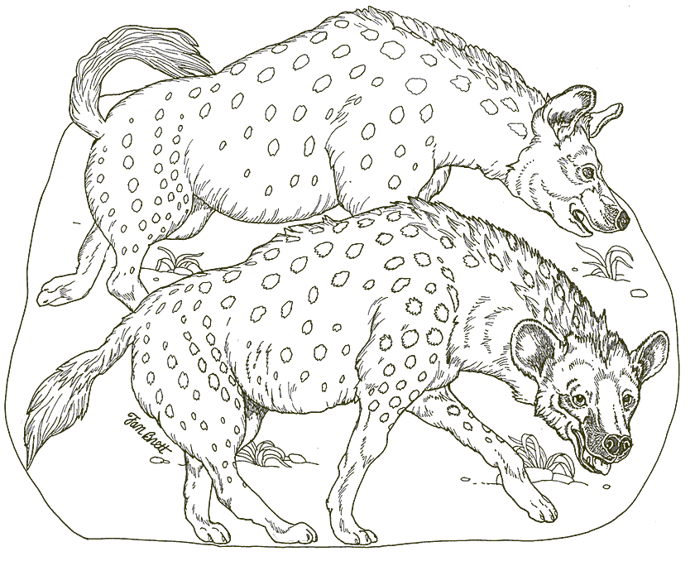

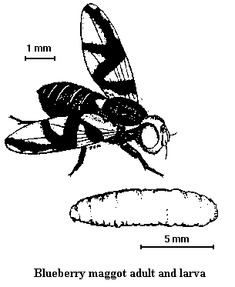
- Decomposers: Consumers that break down the tissues of dead organisms. Examples: maggots, fungi
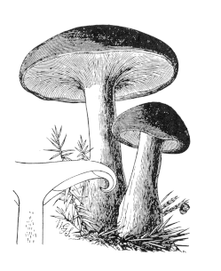

**Food Chain**
Shows how the consumers in an ecosystem are connected to one another according to what they eat. Only 10% of the energy is transferred from one level to the next. Therefore, the higher the animal is on the food chain, the more it has to eat!
ALL ENERGY COMES FROM THE SUN!

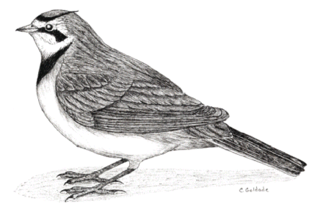
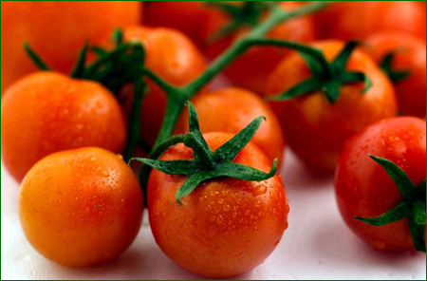
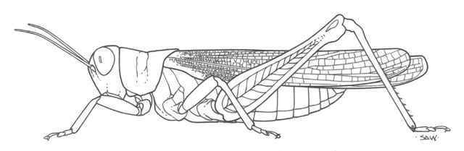

1st level consumer
Herbivore
2nd level consumer
Carnivore
3rd level consumer
Carnivore
4th level consumer
Carnivore
Producer

**Food Web**
Shows a relationship between many different food chains in an ecosystem
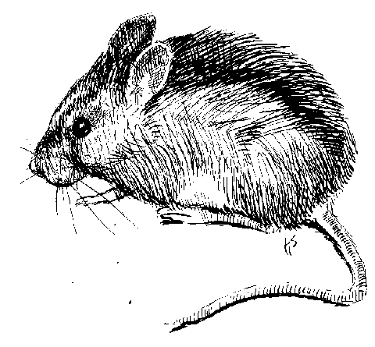
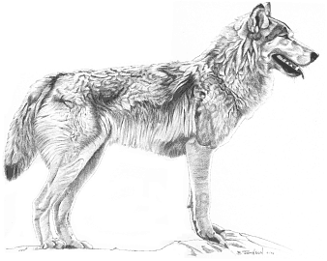
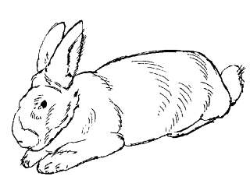
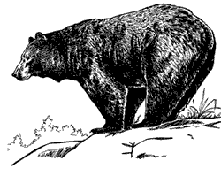

Decomposers return the nutrients to the soil

The arrows are pointing to where the energy is going, not to what an animal is about to eat.

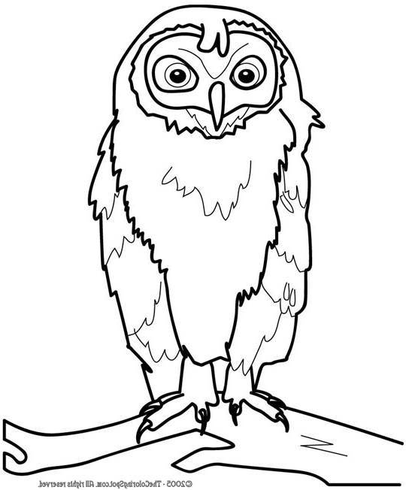

- Eagles eat mice. This keeps the mice from eating all of the plants.
- If there are too many mice, the plants will all be eaten. So, the owls and eagles come eat the mice.
- If there are not enough mice, more plants will grow. The owls and eagles will die or go find food somewhere else.

Populations INTERACT!
The plants breathe carbon dioxide in and give animals oxygen.
Animals breathe in oxygen and give carbon dioxide to the plants.


Limiting Factors
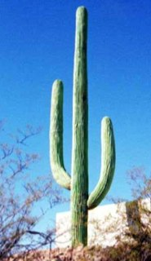
- Environment-The organism must be able to adapt to its environment to survive.
A cactus has shallow roots because it has to be able to soak up rain water quickly. It also has thick stems and leaves in which to store water.

- Amount of Food and Water-There must be plenty of food and water for ALL of the organisms or they will die.

A piece of land with many plants can support many animals.
A piece of land with a few plants could not support very many animals.
OR

Ways In Which Organisms Compete for Resources

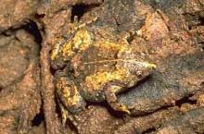
Competition: a contest among organisms for resources
Frog hiding in mud
- Camouflage-patterns of body color
- Prey uses camouflage to hide from predators
- Predators use camouflage to sneak up on their prey.

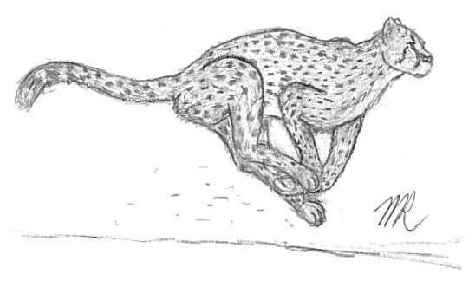
- Speed-
  - Gazelles use their speed to outrun their predators.
  - Cheetahs use speed to chase down their prey.

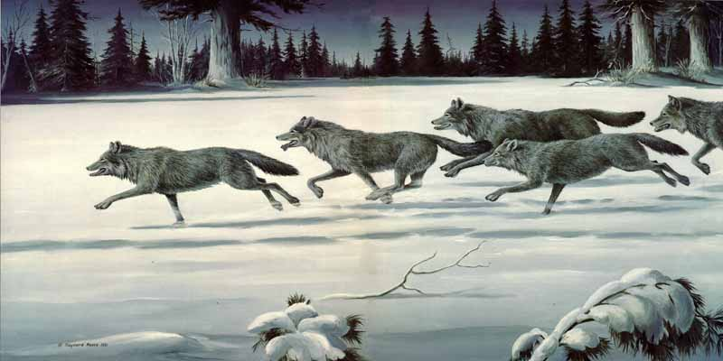
- Hunting in large packs-
  - Hyenas and wolves hunt in groups to intimidate their prey. They can surround an animal or chase a lion away from a killed animal.

Sharing Resources
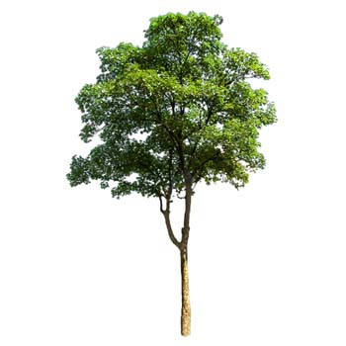
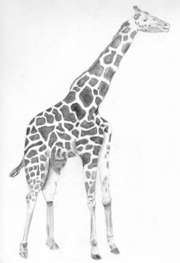
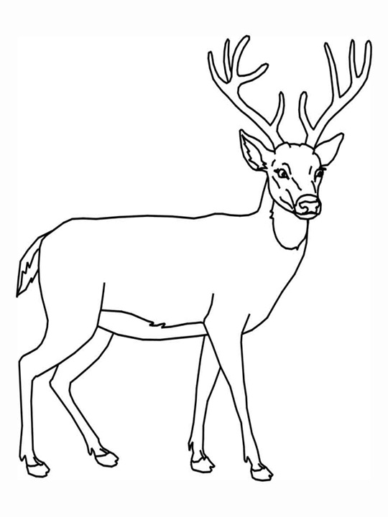
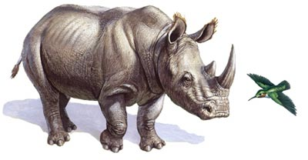
The giraffe will eat leaves from the top of the tree.
The deer will eat leaves from the middle of the tree.
The rhinoceros will eat leaves from the bottom of the tree.

**While these animals may compete for the same tree, they do NOT compete for the same part of the tree. Therefore, they can all share the same resource.**

Symbiosis
A long-term relationship between different kinds of organisms

- Mutualism-a relationship where both organisms benefit.
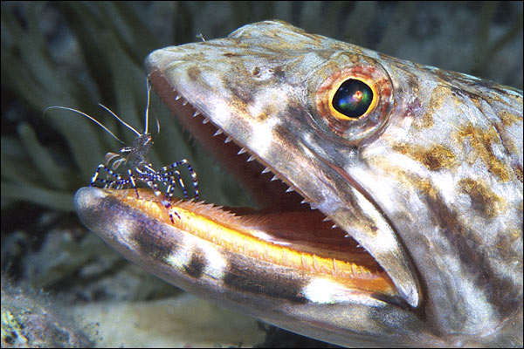
  - A shrimp eats the food from between a fish’s teeth. The fish gets clean teeth and the shrimp gets dinner.

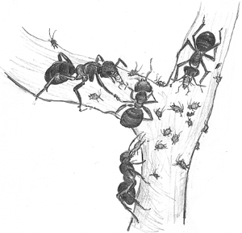

African trees provide shelter and food for ants. Stinging ants protect the tree by killing intruders.

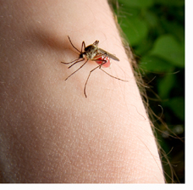
- Parasitism-a relationship between two organisms where one benefits and the other is harmed.
  - When mosquitoes bite humans, they get dinner while the human is left with an itchy sore.

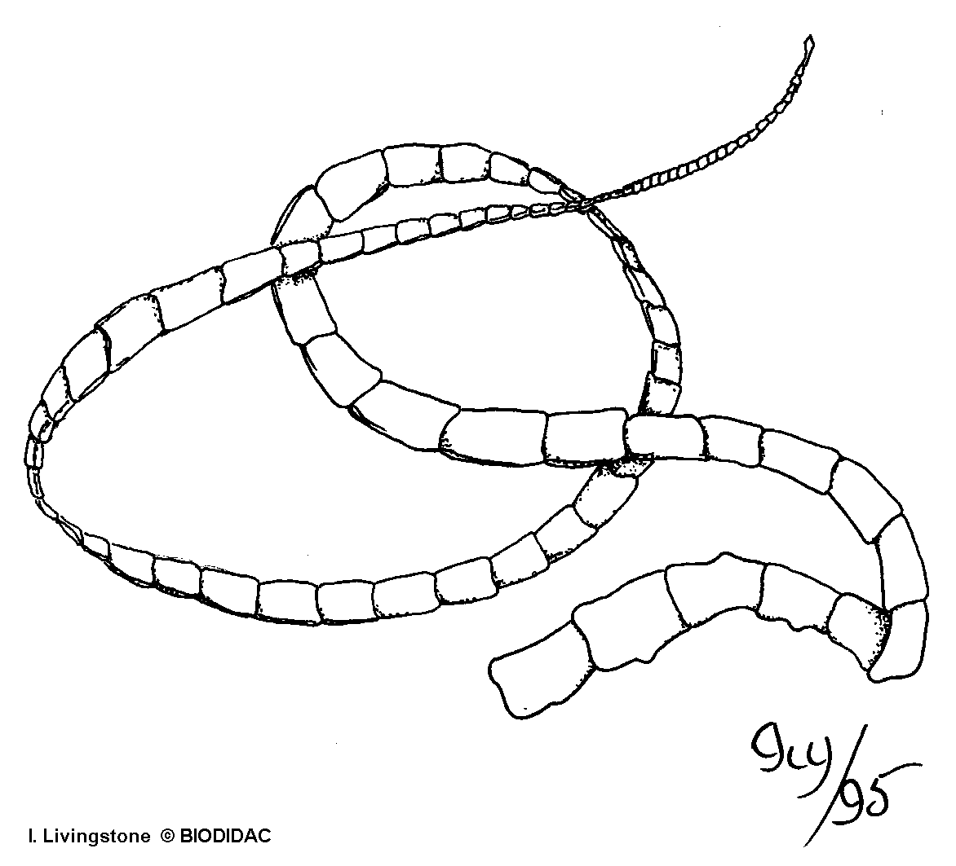
  - A tape worm that lives in a dog’s intestines gets to eat, but the dog is left with a tummy ache and weight loss.

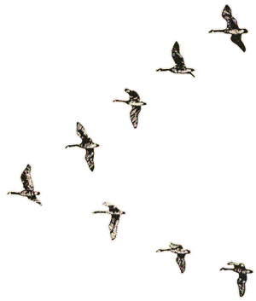
Instincts
Any behavior an organism inherits or is born with

- Canadian geese fly south for winter, mate for life, and eat grains.
- Squirrels bury acorns for winter food.
- Birds build nests.

Learned Behaviors
A behavior an organism learns from its parents
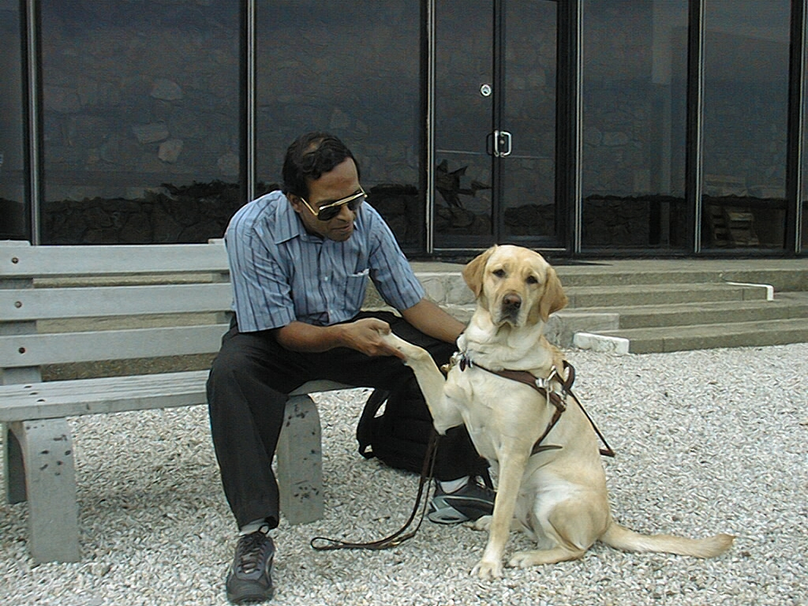
- A dog “shaking hands”

- Parrots “talking”
- Lions have the instinct to hunt, BUT they have to learn hunting skills from their parents.
- Birds have to learn what kind of nest to build and how to build it.

Environmental Change

MAD: Move, Adapt, Die

Adaptation: a change in behavior or physical characteristic that enables an organism to survive changes in the environment.

Short Term Environmental Changes: occur over a short period of time
Ex. Floods, drought,

Organisms can only respond by changing their behavior. There is not time for the species to have develop physical traits.

Long Term Enviroment Changes: changes that last for generations
Ex. Ice Ages, Pollution, Radiation

Organisms that has traits/adaptations that allow them to survive are more likely to live to reproduce and pass those traits on to future generations. SURVIVAL OF THE FITTEST

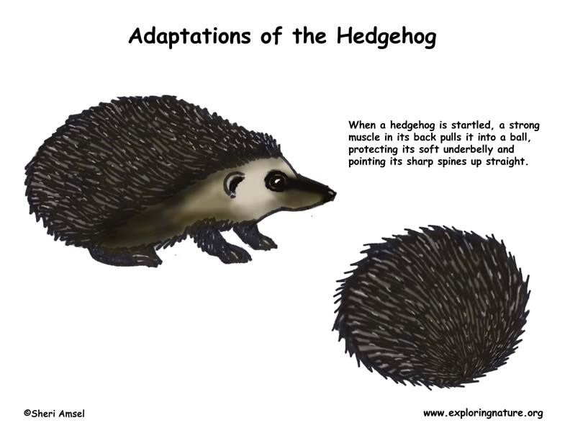
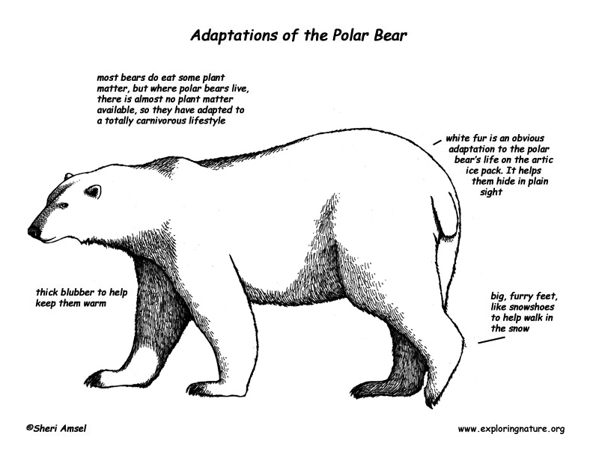
Galapagos Islands, Chernobyl Nuclear Disaster

Humans cause CHANGE!
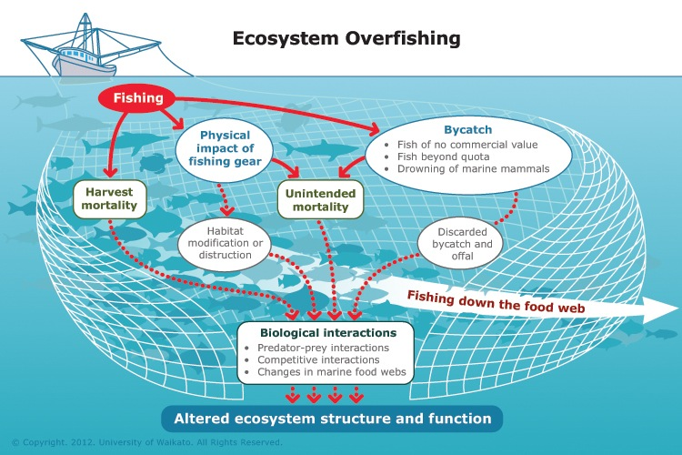
Humans rely on our ocean systems
- Food
- Water cycle
- Weather
- Transportation
- Recreation

Harmful activities: overfishing, pollution, run off, invasive species

Helpful activities: artificial reefs, beach clean ups, animal preserves and protected
areas

Extinction and Its Causes

More humans means:
- More hunting
- More building of new roads, homes, and businesses
- Exotic diseases
*Human import of non-native, or new, animals into the USA. Exotic animals bring diseases here. American animals do not have immunity to them so they become sick easily.

Natural Events:
Most natural events cause temporary destruction, but healthy populations will survive.
- Fires, floods, erupting volcanoes and hurricanes destroy habitats.
- Droughts, or long periods of no rain, may kill the producers (plants). This causes a decline in the consumers because producers supply the rest of the energy pyramid with food.

Levels of Concern

1. Threatened: populations that are likely to become endangered if steps are not taken to protect them (hunting laws especially in relation to elephants and their ivory tusks)

2. Endangered: populations so small that they are likely to become extinct if steps to save them are not taken right away (state and wildlife refuges)

1973 Endangered Species Act: lists organisms according to how small their populations have become.

3. Extinct: last individual in the population dies and is gone forever
(ZERO are left in the population)
Extinction is forever!!

Success Stories
- Bald eagles:
- DDT was a pesticide that softened their egg shells and had made them endangered in the 1960’s.
- 1972: EPA, or Environmental Protection Agency, made DDT use illegal.
- Eagles were raised in captivity and have just recently been taken off of the threatened list.
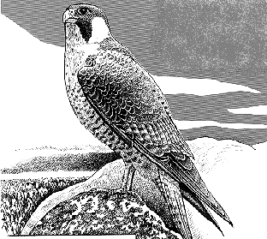
- Peregrine Falcon:
- These huge birds were also hurt by DDT use.
- 1975: There were only 324 pair alive; today there are over 1600 pair alive.
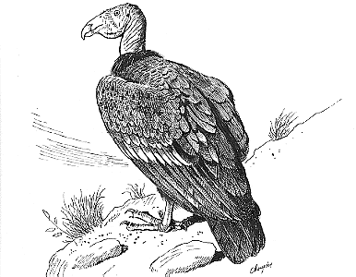
- California Condor:
- These birds are large scavengers.
- 1982: There were only 30 birds alive. Scientists still do not know if this giant bird will ever fully recover.

