**Gutierrez – Magee Expedition**

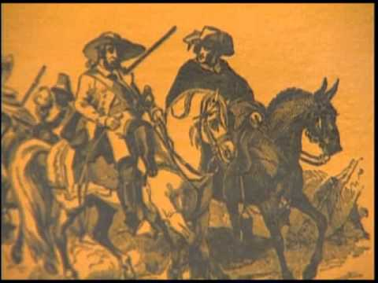

The Mexican Revolution was also taking place in Texas. Before he was captured and killed, Father Hidalgo had sent José Bernardo Gutiérrez de Lara to the United States to recruit soldiers. In the United States, Gutiérrez met another rebel named Augustus Magee. Gutiérrez and Magee created the Republican Army of the North and made plans to free Texas and Mexico from Spanish control. These filibusters were working for the independence of Mexico.

In 1812, Gutiérrez and Magee began by attacking the city of Nacogdoches in East Texas. With the help of the townspeople, the Gutiérrez and Magee army was able to easily defeat the Spanish army. In Nacogdoches, Gutiérrez and Magee shared that they had come with a large army of Americans to free Mexico from the Spanish. With them were many American volunteers who had left their homes to fight for Mexican liberties, just like in the American Revolution.

**Battle of Medina**

[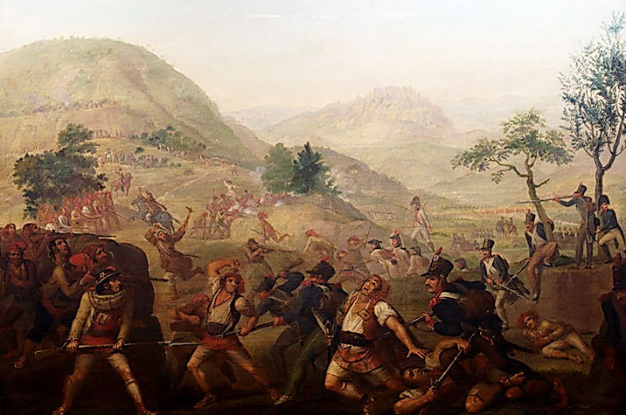](https://www.google.com/url?sa=i&rct=j&q=&esrc=s&source=images&cd=&cad=rja&uact=8&ved=0CAcQjRxqFQoTCJjgoc7D8scCFQaPDQodq2EHUg&url=https://en.wikipedia.org/wiki/Battle_of_Medina_de_Rioseco&psig=AFQjCNFIMS05YX-NEojgrCKEhu8o3GgIQA&ust=1442182762856006)

Pleased by their easy victory in Nacogdoches, Gutiérrez and Magee headed south to San Antonio. Here, however, they encountered resistance from the Spanish army. On August 18, 1813, the bloodiest battle in Texas history took place at the Battle of Medina. The Spanish organized an army of over 1,800 men to stop the rebellion in Texas. They met the 1,400 men in the Republican Army of the North outside of San Antonio in an area called el encinal de Medina. The two armies, although equal in size, were not equal in skill.

The Republican Army of the North was caught off guard and were unprepared for battle. Less than 100 men were able to escape the battle alive. Those who were not killed in the original fight were chased down and executed. The bodies of the fallen soldiers were left to rot where they lay on the battlefield. To retaliate against the city of San Antonio, the Spanish army punished anyone they thought helped in the rebellion. Although the Republican Army did not win this battle, is considered a turning point in the revolution because it encouraged others to participate in the revolution.

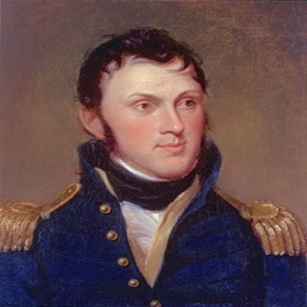**Long Expedition**

**Political events once again inspired filibusters to go to Texas. In 1819, Spain and the United States signed the Adams-Onis Treaty. In this treaty, the United States gave up all claims to Texas in exchange for Florida. The permanent border between the United States and Mexico was established at the Sabine River. Many Americans were angry that the United States had given up all claims to Texas. American filibusters wanted to invade Texas and create an independent country free from Spanish rule. They organized under the leadership of James Long.**

**In June of 1819, the Long Expedition invaded Nacogdoches and proclaimed a new Republic of Texas. Long knew he could not maintain his control of Nacogdoches or claim Texas without help. He journeyed to Galveston Island to gain assistance from Jean Lafitte. Jean Lafitte was a pirate who had taken control of Galveston Island in 1816. Lafitte had established a base on Galveston Island for his piracy operations. He was able to attack ships sailing in the Gulf of Mexico and then flee to safety in Galveston. Lafitte was not interested in creating an independent republic, and he turned James Long down.**

**While Long was in Galveston, the Spanish Army established control over Nacogdoches again. This new republic had only lasted 4 months. But James Long was determined to try again. In April of 1820, James Long again invaded Texas, this time with over 300 men. He brought his pregnant wife Jane with him and set up a fort on Bolivar Peninsula near Galveston. For a year they occupied this location before James Long took his men and attacked Presidion La Bahia. There, he and his men were captured and placed in prison in Mexico City. James Long was later killed by a Spanish guard.**

**His wife, Jane Long, waited for his return during the harsh winter of 1821. Jane and a 12 year old enslaved girl named Kian, faced starvation and were forced to survive by hunting, fishing, and eating oysters. Jane even gave birth alone, with only the help of Kian. They were constantly afraid of an attack by the Karankawa, and fired a cannon every day to make them think the fort was still defended by a large army of men. Her courage during this time, and her efforts later on to colonize Texas, earned Jane Long the title, “Mother of Texas.”**

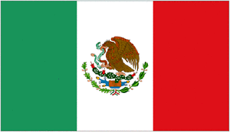 **Mexican Independence**

**In 1820 a rebellion began in Spain. Military leaders sought to force Spain’s king Ferdinand to accept a constitution that limited royal powers. With Spain engulfed in civil war, Spain’s leaders gave little attention to the concerns of the Mexican people. Church leaders and mestizos (a person of mixed Spanish and Native American heritage) had been at the forefront of the Mexican struggle for independence. In time Mexicans of Spanish decent joined the revolution. In the fall of 1820, their leader, Agustin de Iturbide took command of the revolutionary army. Then, in February of 1821, Iturbide issued his plan to establish a Mexican empire.**

**Iturbide’s plan offered a war-weary people of Mexico three guarantees and a plan for government. First, it declared the Mexican people independent from Spain. Second, the Mexican people would unite, with equal rights for mestizos and criollos (Mexicans of Spanish descent). Third, it confirmed the Mexican people’s devotion to the Catholic Church. The new Mexican government was to be a constitutional monarchy with an elected congress of representatives.**

**In the summer of 1821, the Spanish viceroy was replaced. His successor, Juan O’Donojú (oh•don•oh•HOO), arrived in July. Realizing that the Spanish cause was lost, O’Donojú agreed to a treaty with Iturbide. The two leaders signed the Treaty of Córdoba on August 24, 1821. The period of Spanish colonial rule of Texas, which had begun with the first missions in 1682, came to an end. What was once the Spanish colonial province of Texas became a territory of a free Mexico. Although Spain had claimed Texas for 300 years, there had been little growth. Only three settlements—San Antonio, Goliad, and Nacogdoches—existed in Texas’s interior. San Antonio, the capital and the largest town, had about 2,000 people.**

**Mexican Federal Constitution of 1824**

[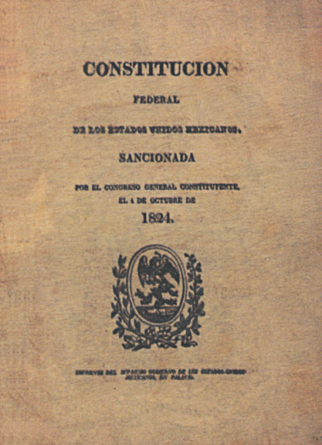](https://www.google.com/url?sa=i&rct=j&q=&esrc=s&source=images&cd=&cad=rja&uact=8&ved=0CAcQjRxqFQoTCOLG05fE8scCFYytgAod4VwAsQ&url=https://en.wikipedia.org/wiki/1824_Constitution_of_Mexico&bvm=bv.102537793,d.eXY&psig=AFQjCNEsn8ind8HbdjLWyUqvWUec4Fr3qg&ust=1442182914247199)

Constitutional government in Texas began with the Mexican Federal Constitution of 1824, which to some degree, was patterned after the United States Constitution. The Constitution was written after Mexico’s independence from Spain. The republic took the name of United Mexican States. The Catholic religion was made the official religion; and the church was supported by the public treasury.

The Constitution stated that the president and vice president would be elected for a four year term by the legislative bodies of the states. The Lower House of Congress would elect in case of a tie or lack of a majority. The president’s power would be limited. Congress was made of 2 houses which met annually from January 1st to April 15th. The Constitution created the state of Coahuila y Teas, merging the two provinces. (Texas & Coahuila)

**Merger of Texas and Coahuila (Coahuila y Tejas)**

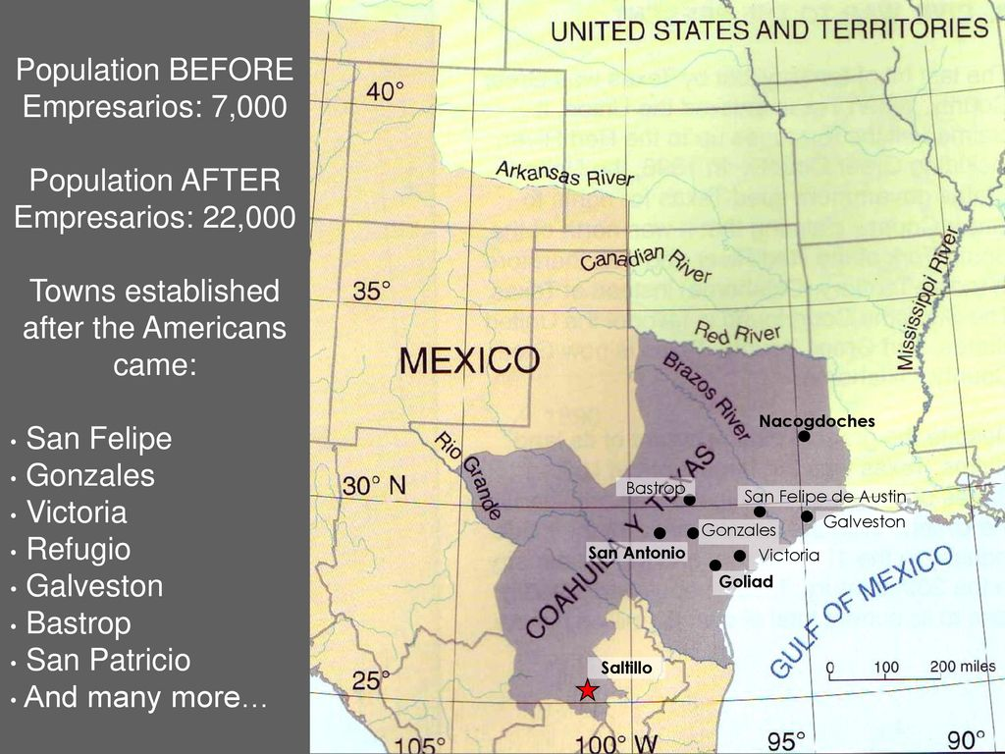

By the Constitution of 1824, the Mexican provinces of Nuevo Leon, Coahuila, and Texas were united as one state. Nuevo Leon was detached, a Congress was elected and assembled and a governor was named for the state. A provisional chief was appointed in Texas and the Department of Texas was legally established as a subdivision of the state of Coahuila and Texas. A Constitution for Coahuila and Texas adopted on March 11, 1827. Texas was not organized as a separate state because of its small size.

**State Colonization Law of 1825**

The State Colonization Law set up guidelines to the colonization of Coahuila y Tejas. It allowed Stephen F. Austin and other Empresarios to receive land grants in Texas. An Empresario is a land agent whose job is to bring new settlers into an area. It focused primarily on the immigration of Coahuila and Texas and attempted to encourage farming, ranching, and settlement in Mexico.

Families could obtain 4,428 acres of pasture land and approximately 177 acres of farm land. The cost to purchase land in this area was very cheap. The law required settlers to become Mexican citizens and promise to become Catholics. People flocked to Saltillo, the capital of Coahuila y Tejas when they learned of the law.

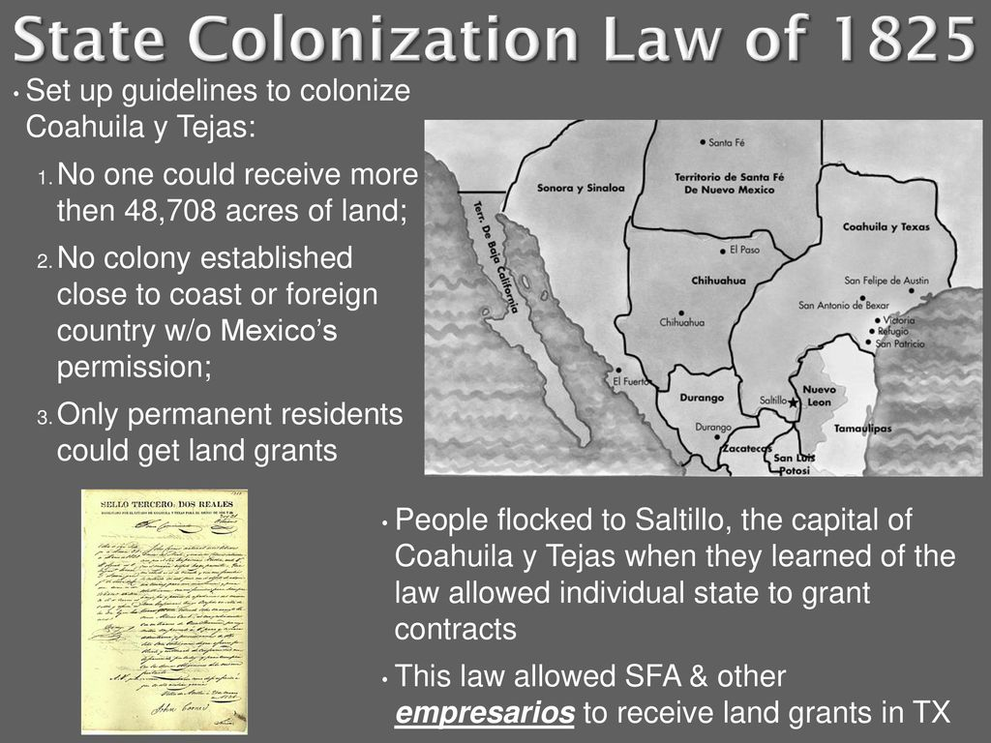

**Issue of Slavery**

[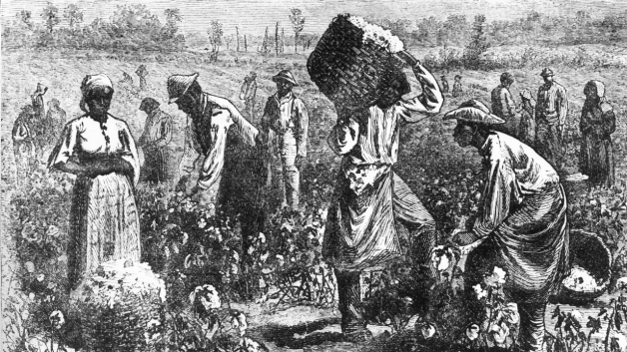](http://www.google.com/url?sa=i&rct=j&q=&esrc=s&source=images&cd=&cad=rja&uact=8&ved=0CAcQjRxqFQoTCNfwypPP8scCFQmYgAodOF4ESA&url=http://935972732488443890.weebly.com/&bvm=bv.102537793,d.eXY&psig=AFQjCNEYGzRB629OIP8rdE8OmNMU2UvhJw&ust=1442185806560216)

In **1821** colonists could bring slaves to Mexican Texas and buy land depending on the number of slaves brought. Mexico offered full citizenship to free blacks, allowing land ownership and other privileges. In **1823,** the sale and purchase of slaves was forbidden in Texas, and required that the children of slaves be freed when they reached the age of fourteen.

In **1827**,the legislature of Coahuila y Tejas outlawed the introduction of additional slaves and granted freedom at birth to all children born to a slave. In **1829,** Mexico abolished slavery, but it granted an exception to Texas. In **1830,** importation of slaves was illegal in Texas. Before the arrival of Austin’s colonists, few enslaved people lived in Spanish and Mexican Texas. Southern farmers, however, brought many enslaved African Americans in Texas, using their labor to produce cotton crops and to perform other tasks.

One-fourth of Austin’s colony included enslaved African Americans. The law outlawed buying and selling of people, but it did not prevent colonists from keeping enslaved people. In 1829, Mexico passed a law ending slavery, and the country became a refuge for African Americans who had run away from slaveholders in Texas and U.S. However, the law was not enforced in Mexican Texas. By 1836, 5,000 enslaved African Americans lived in Texas.