Turkey in Disguise Activity 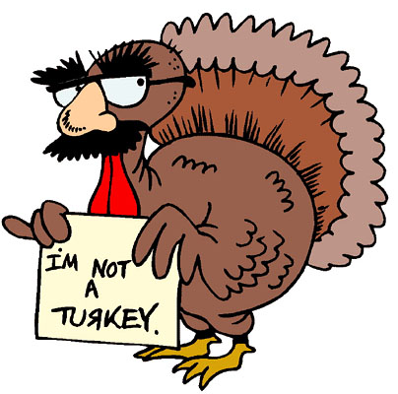
Your mission is to come up with a turkey disguise to keep your feathered friend, the turkey from becoming the main attraction of the traditional Thanksgiving meal. Be creative. There are a ton of ideas, tips, and tricks on how to disguise your feathered friend.

I will accept disguised turkeys through the month of November, and I’ll display them around the circulation desk.

These instructions and a copy of the turkey you need to disguise will be available at the circulation desk, and both have been posted on the Kranz Library website on Dickinson ISD.

I am encouraging faculty/staff and students to participate.

You can find some ideas to inspire you here:
https://findingmandee.com/2018/11/08/best-turkey-disguise/
