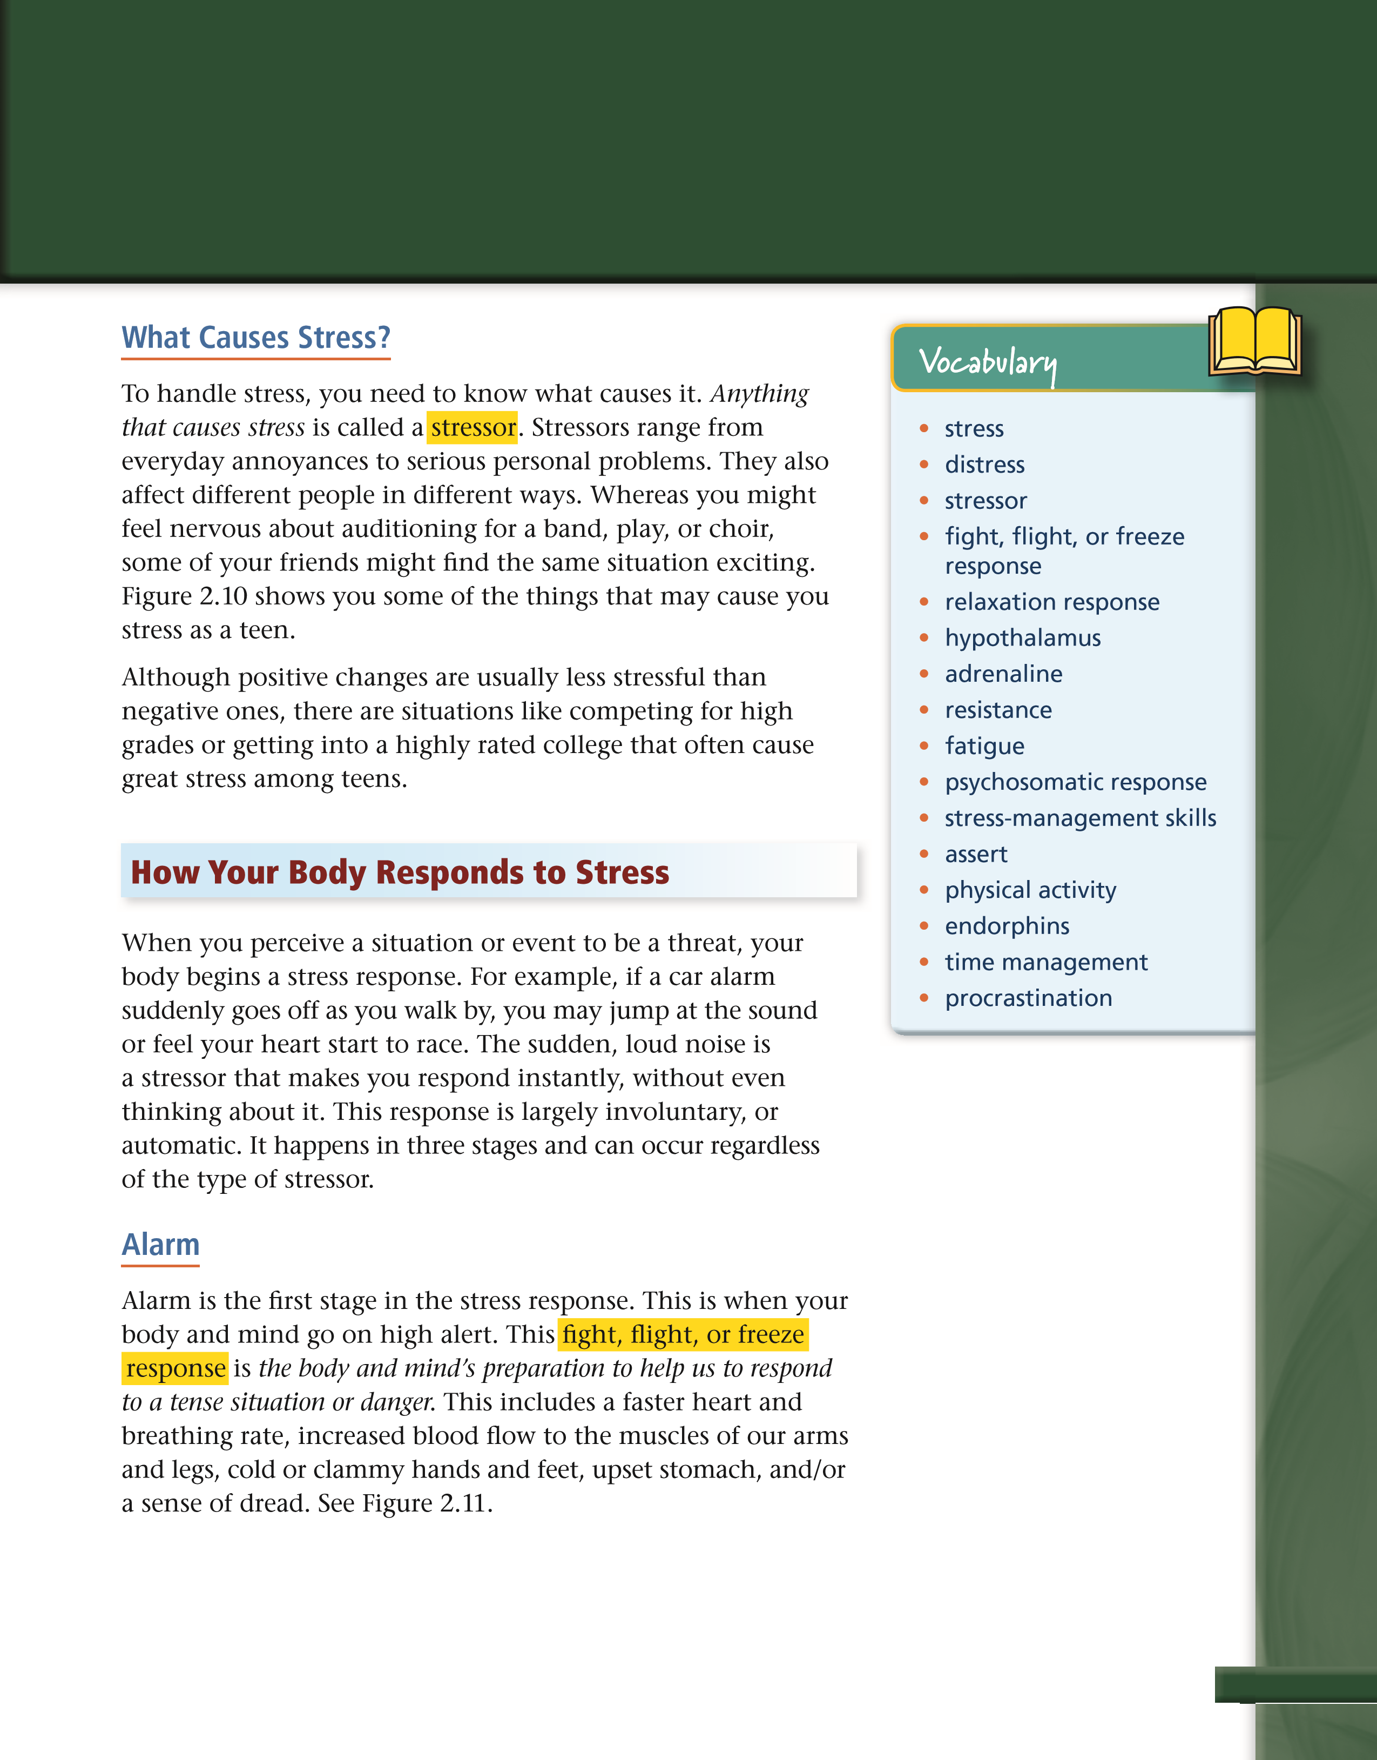
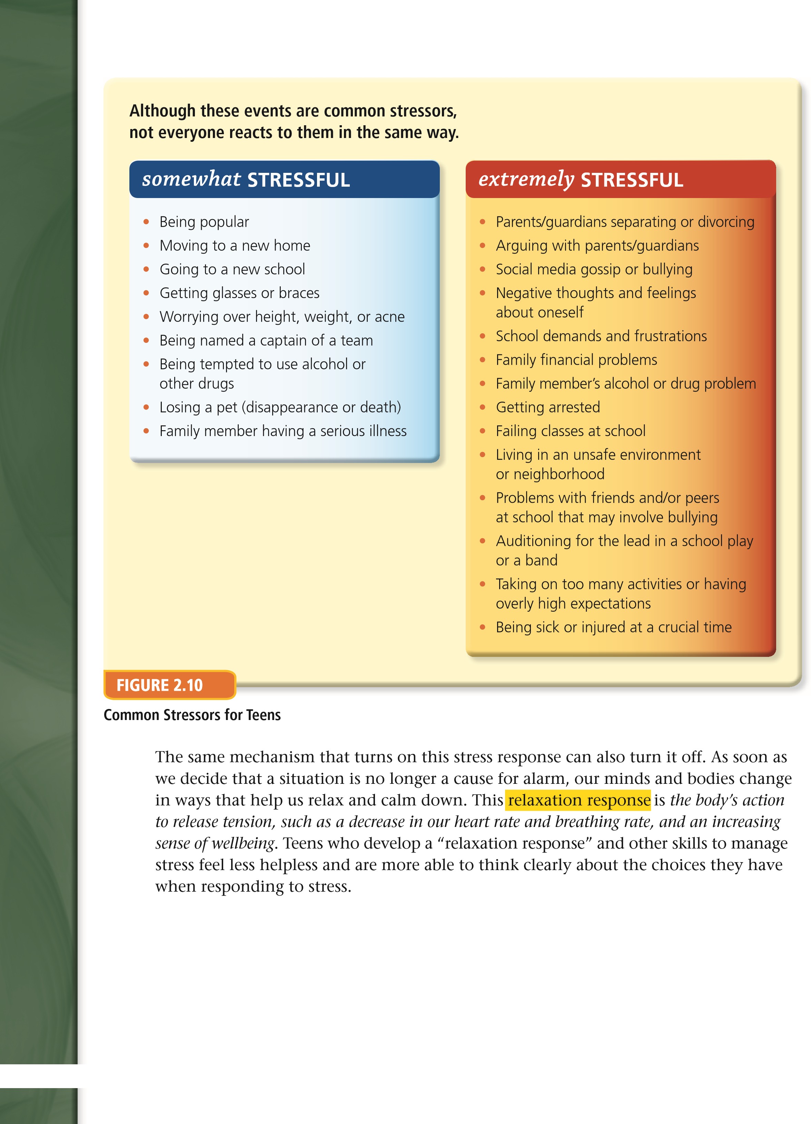

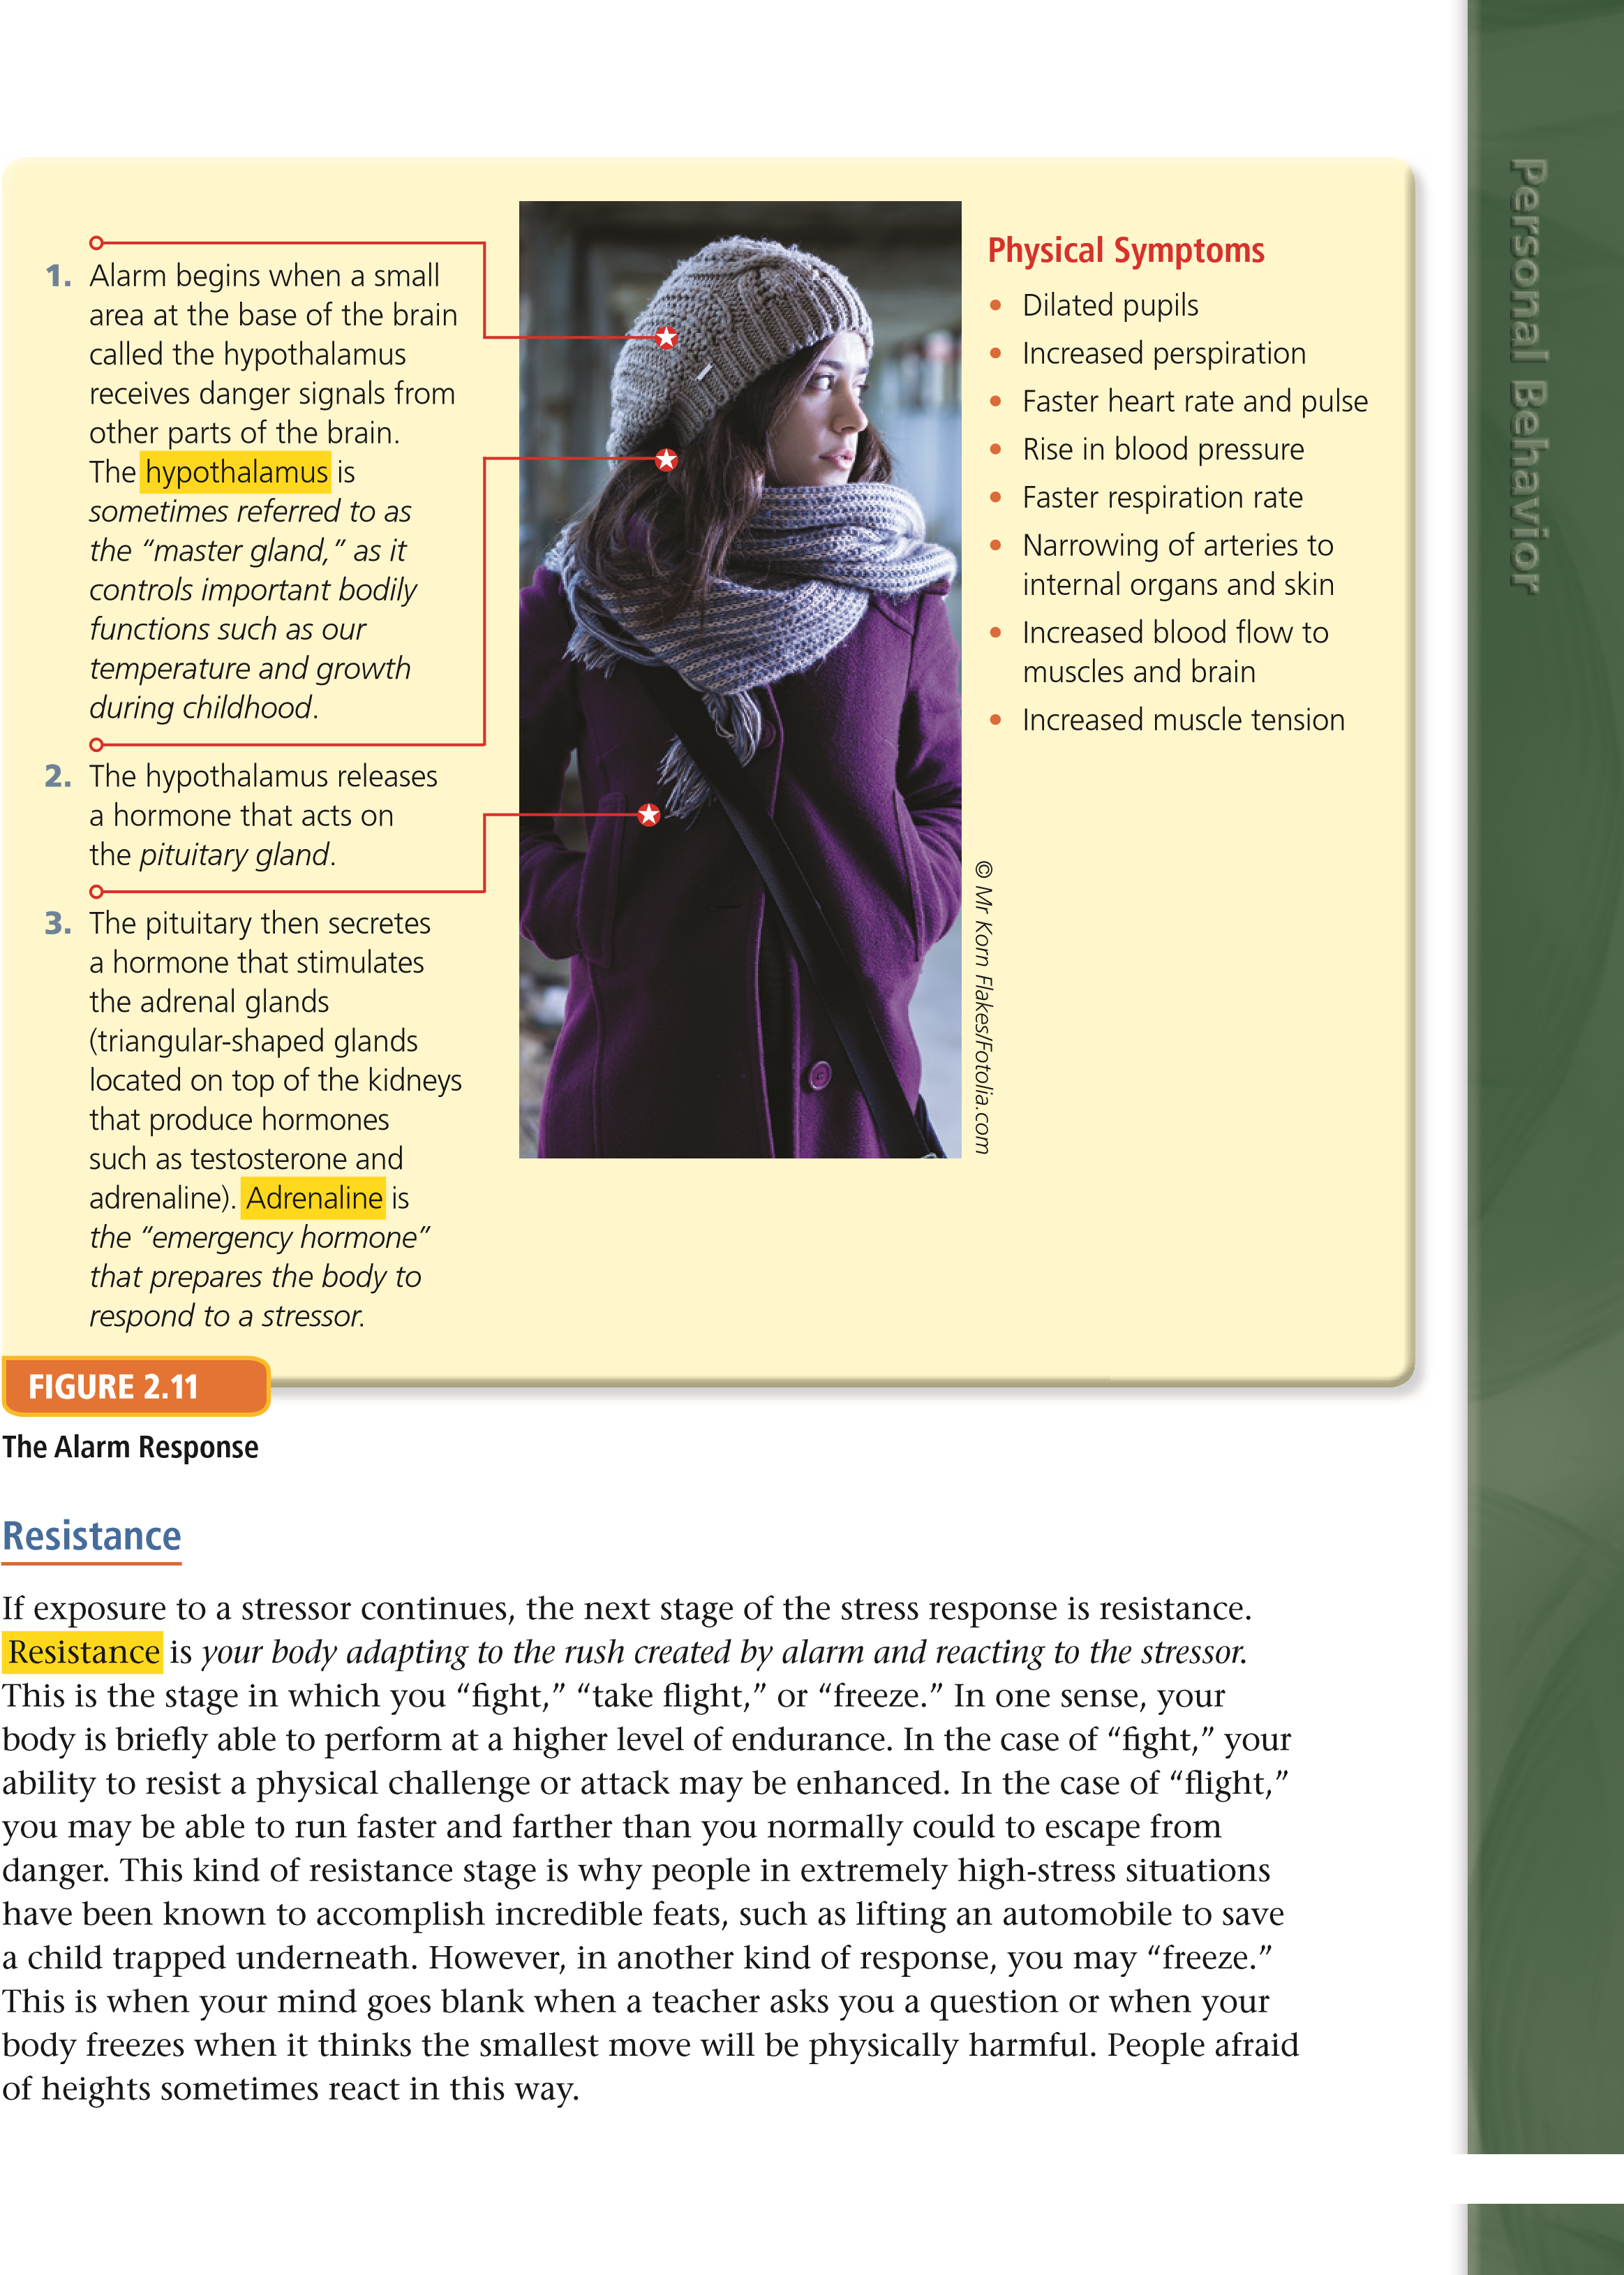

Fatigue
Fatigue is the body losing its ability to adapt to a situation when exposed to prolonged periods of stress. During fatigue, the third stage of the stress response, an exhausted feeling takes over your mind and body. This lowers your level of activity. In this stage, your ability to manage other stressors effectively is very low.
Fatigue can affect your body in several ways:
- Physical fatigue results when your muscles work very hard for long periods, often leading to soreness and pain. Reaction time is impaired, and muscles tire very quickly.
- Psychological fatigue can result from many things. Among them are constant worry, overwork, depression, boredom, isolation, or feeling overwhelmed by too many responsibilities.
- Pathological fatigue is brought on when your body’s defenses are overworked in fi ghting disease. Cold or fl u, being overweight, and poor nutrition can bring on pathological fatigue. If you use drugs such as alcohol, this can intensify the feeling of fatigue.
Long-term stressful events can lead to illness. This is because changes take place in your body during any of the three stages of resistance. A recent study revealed that people who are always stressed release an excessive amount of a hormone called cortisol.
Physical Symptoms
•
Lack of energy
•
Fatigue
•
Headaches
•
Sweaty or cold hands and feet
•
Ulcers
•
Problems sleeping
•
Nightmares
•
Apathy
•
Anxiety
•
Depression
•
Confusion
•
Muscle tension
•
Hives
Behavioral Symptoms
•
Low self-esteem
•
Inability to focus
•
Irritability, anger, or tantrums
•
Suicidal thoughts or attempts
•
Withdrawal
•
Crying
•
Nail-biting or grinding teeth
•
Overeating or under-eating
•
Lying
•
Moodiness
•
Stealing
•
Violence
•
Chain smoking
•
Drug or alcohol use
Symptoms of Stress in Teens
Cortisol normally helps a body’s immune system response. However, people who are constantly stressed release too much cortisol. The body’s immune cells then become insensitive to cortisol’s normal regulatory effect. The research suggested that this reaction can promote disease, including the common cold.
Although a stress-related illness can be minor, such as sleep troubles or upset stomach, it can also be life-threatening. Over an extended period, high blood pressure can develop, or the risk of heart disease or stroke may increase. Even stressors that are often ignored, such as the hassles of a daily routine, can build up over time and cause physical and psychological problems.

Stress and Your Health
Stress is an unavoidable part of life. As mentioned before, stress can make life fun, exciting, enjoyable, and challenging. However, excessive or prolonged stress can have a negative impact on all aspects of your health.

Physical Effects
Sometimes stress can lead to a psychosomatic response. This is a physical reaction that results from stress rather than from an injury or illness. The prefi x psycho means “of the mind,” and somatic means “of the body.” Psychosomatic responses may include sleep disorders, skin disorders, and stomach and digestive problems. Other health problems that may sometimes be stress-related include:
Personal Behavior
- Headaches—A headache caused by stress is the most common type of headache. When stressed, the muscles in the head and neck contract. Migraine headaches, which affect about one in ten people, may also be triggered by stress. During a migraine attack, infl amed blood vessels and nerves around the brain cause severe throbbing, which is often accompanied by nausea and vomiting.
- Weakened immune system—Extended exposure to stress can reduce your body’s ability to fi ght disease by weakening the immune system. When your immune system is weakened, you may be more prone to colds, fl u, or more severe infections. You may also experience a great deal of muscle tension and develop hives or other skin disorders.
- Anxiety—A feeling of severe anxiety can bring on other symptoms such as nightmares, confusion, and depression. It can even bring on stress-related ulcers.

Behavioral Effects
Stress can also have effects on mental, emotional, and social health. It can interfere with daily activities and relationships with others. For example, stress can make it hard to focus. This can cause some “self-put-downs” and the distorted belief that failure is inevitable.
The Impact of Tension-Related (Stress) Headaches
There are estimates that in any given year about 70 percent of some populations worldwide have at least one headache due to tension.
In the United States, about 30 to 80 percent of the adult population suffers from occasional tension headaches. Women are twice as likely to suffer from them as men are.
In a large 2001 British study, about 8 percent of 7-year-olds and 15 percent of 11-year-olds had headaches. Headaches occurred most often around age 13. The study further reported that many of these children tended to have headaches and other physical complaints when they grew up.
In the study, signifi cant factors associated with childhood headaches included:
- Moderate or severe depression.
- Separation from the mother for more than a week.
- Chronic illness in the mother when the child was younger than 11.
- Mental illness in any family member.
Another study done in 2001 concluded that young people with headaches tended to be more emotionally rigid. They also tended to have more repressed anger than their peers.
Mood swings are also a common reaction to stress. Teens often experience mood swings as a result of hormonal changes and social and academic pressures. These emotional shifts from happy feelings to depression-like symptoms may put a strain on relationships with family and friends.
Stress can increase a person’s vulnerability to alcohol, tobacco, or drug use. Many people give stress as the reason they started drinking or smoking. However, use of these substances actually increases stress and leads to even bigger problems.
In some cases, stress can lead to more serious behaviors like lying, stealing, and even physical violence.

Identifying Stress
The fi rst step in stress management is to identify the source of the stress. To help identify your personal stressors, look at what is happening around you right now. Are any of the following causing you stress?
- Life events—These may include moving or relocating; adding family members by marriage, birth, or adoption; being ill; or parents’ divorce or separation.
- Physical stressors—These may include being physically injured, lacking sleep or rest, using drugs or alcohol, eating or dieting excessively, or not getting exercise.
- Daily hassles—Feeling too many time or social pressures or having too many responsibilities are among these types of stressors, as well as confl icts with your surroundings, or with friends and fellow students, teachers, neighbors, or family.
Positive Ways to Manage Stress
There is no way to eliminate stress completely from your life; accept that throughout your life, you will encounter different levels of stress. To handle stress so that it has a positive result, you need a variety of stress management skills, or ways to prevent and overcome problems related to stress. One of the basic ways to manage stress is to follow a healthy lifestyle that includes a good diet, rest, and regular exercise. Problems are always easier to deal with if you feel well. You can also reduce your own stress by:
- Knowing how and when to relax
- Keeping a positive outlook
- Keeping a sense of humor
- Learning to be assertive
- Ignoring circumstances that can’t be changed
- Being physically active
- Finding a hobby you enjoy
- Eating healthy
- Seeking supporters to help you cope
- Solving small problems to increase your confi dence

Relax
Personal Behavior
When you relax, you reduce stress by slowing your heart rate. This makes you feel less tense. You can try a few of these techniques:
- Relax your muscles—Tighten and then relax one group of muscles at a time. Start at your toes and work your way up to your head.
- Slow your breathing—Take deep, even breaths for fi ve minutes. Inhale through your nose, expanding your abdomen, and exhale slowly through your mouth.
- Get enough sleep—Feeling overly tired can make a stressful situation seem worse. It seems too simple, but things do seem better after a good night’s sleep!
- Try meditation—Find a quiet place where you can be alone for 10 minutes. Sit on the fl oor or a chair, keeping your back straight, close your eyes, and try to empty your mind. Concentrate on slow breathing, focusing on a single word, image, or sound.

